HEATING EFFECT OF AN ELECTRIC CURRENT

- State three factors which affect heating by an electric current.

- State the energy changes which occur when one switches on a torch. (2mk)

- What is power as it relates to electrical energy?

- Name the device which changes;
(i) Sound to electrical energy (1mk)
(ii) Electrical energy to kinetic energy (1mk)

- Figures shows a simple water heater.

B

A

Give a reason why AB is coiled. (1mk)

- Fig represents part of electric cooker coil.
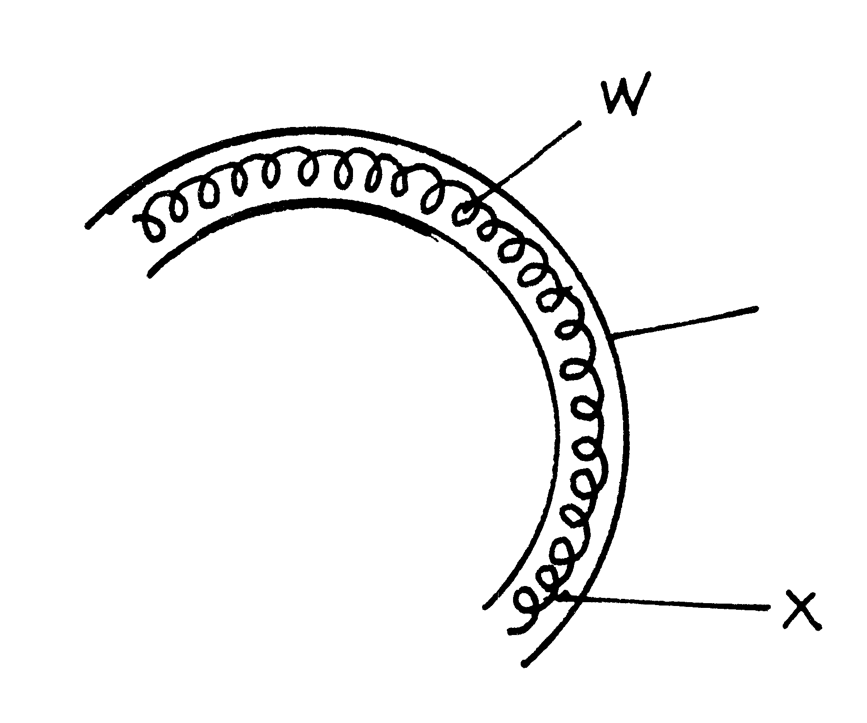
X

(i) Why is the material labeled X is coiled? (1mk)
(ii) State the property of material X that makes it suitable for its use. (1 mk)

- An electric heater is found to have a resistance of 950Ω when operating normally on a 240V mains. Find the power rating of the heater. (2mk)

- An electric bulb rated 40W is operating on 240V mains. Determine the resistance of its filament

- An Electric heater is rated 1000W, 240V. Calculate the resistance of this element

- When a current of 2A flows in a resistor for 10 minutes, 15kJ of electrical energy is dissipated. Determine the voltage across the resistor.

- How many 100W electric irons could be safely connected to a 240V moving circuit fitted with a 13A fuse? (2mk)
- An electric bulb with a filament of resistance 480Ω is connected to a 240V mains supply. Determine the energy dissipated in 2 minutes. (3mk)

- An electrical appliance is rated as 240V, 200W. What does this information mean?

- An electrical heater is labelled 120W, 240V. Calculate;
a) The current through the heating element when the heater is on.
b) The resistance of the element used in the heater.

- An electric bulb with a filament resistance 300Ω is connected to a 2V main supply, determine the energy dissipated in 2 minutes.

- An electric toy is rated 100W, 240V. Calculate the resistance of the toy when operating normally.

- Find the maximum number of 75W bulbs that can be connected to a 12A fuse on a 240V mains supply. (3mks)

- A bulb is labelled 12V, 36W, when used on a 12V supply. What current will it take? (1 mk)

- A car battery is used to light a 12V lamp A constant current of 3 A passes round the circuit.
- Explain what happens to the energy of the electron as they flow through the lamp wire. (3mks)
- How much energy is transferred by the lamp in 20 seconds?(2mks)

- An electric kettle is rated 3kW, 250V. Determine the resistance of the coil.
(3mks)
- Two electric heaters A and B rated 1000 W and 2500 W respectively are connected in parallel across a 240 mains supply. Calculate the ratio R_{A}: R_{B} of their resistances. (3mks)

- An electric bulb is rated 75W, 240V. Determine the resistance of the bulb.

(3mks)
- A wire made from some alloy has a resistance of 2.0 ohms per metre. What length of this wire would be required to make a heating coil of rating ‘240V, 1kW’ (3mk)

- A total charge of 360 coulombs is passed through an 80 ohms resistor in 30 seconds. Determine the amount of heat energy generated. (3 mks)

- An electric bulb with a filament of resistance 480Ω is connected to a 240V mains supply. Determine the energy dissipated in 2 minutes.

- A washing machine for use on 240V mains has a ¹/₃h.p motor and a heating element rated 3Kw.( 1h.p = 0.75kw) . What current does it take it take when in use (3mks)

- The circuit shows two bulbs A and B connected in parallel to each other. Which bulb will light brighter? Give a reason for your answer. (2mk)
1440 Ω

12V

960 Ω

Bulb A
Bulb B

a) Why are the elements of domestic heating appliances made of nichrome?
wire instead of tungsten wire. (1mk)
b) What property does a fuse wire have that make it suitable for controlling excessive currents in circuits? (1mk)
c) What do you understand by rating 150w, 240v indicated on an electric bulb? (2mk)

- Calculate the heat energy dissipated by a bulb rated 240W working for 10 min
(3mk)

